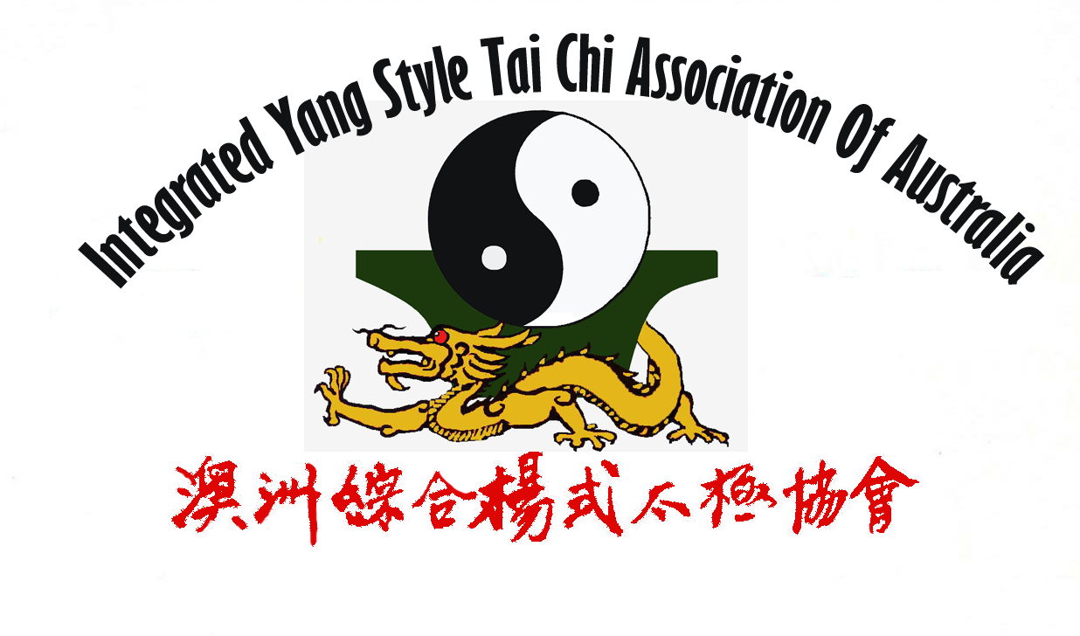
简易综合杨式太极拳拳势
The Patterns of Simplified Integrated Yang Style Tai Chi

教练：方文洪医生 (外科大夫) Instructor: Dr. B. H. Hong (Surgeon)

太极拳术要领 The essences of Tai Chi practice

- 虚灵顶劲 Xu Ling Ding Jing
- 含胸拔背 Han Xiong Ba Bei
- 松腰松胯 Song Yao Song Kua
- 虚实分明 Xu Shi Fen Ming
- 沉肩堕肘 Chen Jian Duo Zhou
- 气沉丹田 Chi Chen Dan Tian
- 用意不用力 Yong Yi Bu Yong Li
- 上下相随 Shang Xia Xiang Sui
- 内外相合 Nei Wai Xiang He
- 相连不断 Xiang Lian Bu Duan
- 动中求静 Dong Zhong Qiu Jing

呼吸符号: 吸 ↓ ,呼 ↑
Symbols for Breathing: Breathe in ↓, Breathe out ↑

全套动作顺序及名称:
The sequence and the names of the movements used throughout the whole set:

太极拳预备式: Preparation of Tai Chi.
手心向下↓↑, 右脚分开↓↑. Palms downward; Right foot step aside.
Shou Xing Xiang Xia, You Jiao Fen Kai

- 太极起势 ↓↑ | Beginning of Tai Chi↓↑.
Tai Ji Qi Shi,
- 左右野马分鬃 | Left and Right Parting the wild horse’s mane:
Zuo You Ye Ma Fen Zong
(1)左野马分鬃↓↑ | (Left) Parting the wild horse’s mane↓↑.
Zuo Ye Ma fen Zong
(2)右野马分鬃↓↑ | (Right) Parting the wild horse’s mane↓↑.
You Ye Ma fen Zong
(3)左野马分鬃↓↑ | (Left) Parting the wild horse’s mane↓↑.
Zuo Ye Ma Fen Zong
- 白鹤亮翅 ↓↑ | The white crane spreads its wings.↓↑.
Bai He Liang Chi
- 左右搂膝拗步 | Left and Right brush knee and step forward:
Zuo You Lou Xi Ao Bu
(1)左搂膝拗步 ↓↑ | Left brush knee and step forward↓↑.
Zuo Lou Xi Ao Bu
(2)右搂膝拗步↓↑ | Right side brush knee and step forward↓↑.
You Lou Xi Ao Bu
(3)左搂膝拗步↓↑ | Left side brush knee and step forward↓↑.
Zuo Lou Xi Ao Bu
- 手挥琵琶 ↓↑ | Play the lute↓↑.
Shou Hui Pi Pa
- 左右倒撵猴 | Left and Right repulse the monkey:
Zuo Yuo Dao Nien Hou
(1)左倒撵猴↓↑ | Left repulse the monkey↓↑.
Zuo Dao Nien Hou
(2)右倒撵猴↓↑ | Right repulse the monkey↓↑.
You Dao Nien Hou
(3)左倒撵猴↓↑ | Left repulse the monkey↓↑.
Zuo Dao Nien Hou
(4)右倒撵猴↓↑ | Right repulse the monkey↓↑.
You Dao Nien Hou
(5)左倒撵猴↓↑ | Left repulse the monkey↓↑.
Zuo Dao Nien Hou
- 左揽雀尾 ↓, 堋↑,捋↓,挤↑,按↓↑ | Left grasp sparrow’s tail↓ and
Zuo Lan Que Wei, Pen, Lü, Ji, An | Ward off↑; Roll back↓; Press↑; Push↓↑.
- 右揽雀尾 ↓, 堋↑,捋↓,挤↑,按↓↑ | Right grasp sparrow’s tail ↓and
You Lan Que Wei, Pen, Lü, Ji, An | Ward off↑; Roll back↓; Press↑; Push. ↓↑
- 单鞭↓↑ ↓↑ | Single whip↓↑↓↑.
Dan Bian
- 云手（五次）↓↑ ↓↑ ↓↑ ↓↑ ↓ | Wave hands in cloud (Five times) ↓↑ ↓↑ ↓↑ ↓↑ ↓.
Yun Shou
- 单鞭 ↑ | Single whips↑.
Dan Bian
- 高探马↓↑ | Stand high search for horse↓↑.
Gao Tan Ma
- 右蹬脚↓↑ | Kick with the right heel↓↑.
You Deng Jiao
- 双风贯耳↓↑ | Strike the ears with both fists↓↑.
Shuang Fen Guan Er
- 转身左蹬脚↓↑ | Turn around and kick with the left heel.↓↑
Zhuan Shen Zuo Deng Jiao
- 单鞭 ↓↑ | Single whip↓↑.
Dan Bian
- (蛇身)下势 ↓↑ | Snake creeps (down)↓↑
(She Shen) Xia Shi
- 左右金鸡独立 | Golden roster stands on one leg left and right:
Zuo You Jin Ji Du Li
(1)左金鸡独立↓↑ | Golden roster stands on one leg left↓↑.
Zuo Jin Ji Du Li
(2)右金鸡独立↓↑ | Golden roster stands on one leg right↓↑.
You Jin Ji Du Li
- 左右玉女穿梭 | Jade lady threads shuttle left and right:
Zuo You Yu Nü Chuan Suo
(1)左玉女穿梭↓↑ | Jade lady threads shuttle left↓↑
Zuo Yu Nü Chuan Suo
(2)右玉女穿梭↓↑ | Jade lady threads shuttle right↓↑.
You Yu Nü Chuan Suo
- 海底针↓↑ | Pick up a needle from sea bottom↓↑.
Hai Di Zhen
- 肩通背↓↑ | Fan going through back↓↑.
Jian Tong Bei
- 白蛇吐信 ↓↑ | White snake spits venom↓↑.
Bai She Tu Xing
- 转身撇身锤↓↑ | Swing back and punch↓↑.
Zhuan Shen Pie Shen Chui
- 进步搬拦锤↓↑ ↓↑ | Step forward; deflect downward and punch↓↑ ↓↑.
Jin Bu Ban Lan Chui
- 如封似闭↓ | Like sealed as if closed↓.
Ru Feng Shi Bi
- 按↑ | Push↑.
An
- 十字手↓↑. | Cross hands↓↑.
Shi Zi Shou
- 合太极 ↓↑ | Complete Tai Chi↓↑.
He Tai Ji

Prepared by Val Sun, 31 July 2026, Melbourne

